# Tizen Platform Overview

## Objective

In this chapter, you will examine the concepts, features, and components that identify Tizen apps. You'll look at user interface conventions, application components, and device features.

## Contents

### Tizen Open Source Information

Tizen provides web sites with list of free tools, SDKs and documentations.

Visit

* <http://www.tizen.org>
* <http://developer.tizen.org/sdk>
* <http://source.tizen.org/>
* <https://developer.tizen.org/documentation>

Community

* Mailing lists: <http://www.tizen.org/community/mailing-lists>
* IRC Channel: #tizen
* Wiki: <https://www.tizen.org/community/wiki>
* JIRA: <http://bugs.tizen.org>

### Architecture of Tizen

Tizen is a standards-based platform that provides Web APIs for developing applications for multiple device categories. Tizen is currently targeted for smart phones and tablet devices, though planned to cover more device types in the future. The following figure illustrates the Tizen architecture.

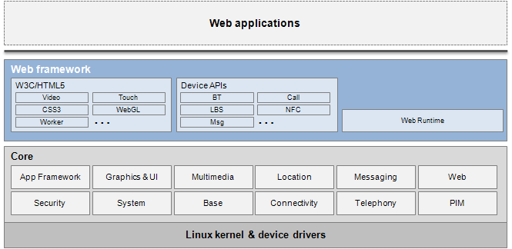

The Tizen architecture consists of the following subsystems:

* **Web framework.** The Web framework accommodates and leverages most up-to-date Web technologies. It provides a large number of HTML5 functionalities defined by W3C and other standardization groups, such as video, audio, form, 2D canvas, WebGL, CSS3, geolocation, vibration, Web socket, and Web worker. In addition, the framework defines various new device APIs, which enable you to access device functionalities, such as Bluetooth, near field communication (NFC), alarm, and messaging. The device functionalities are provided with a strict rule-based security control system that restricts the malicious use of the device APIs.
* **Core.** The Core subsystem provides features required by the Web frameworks. It consists of open source libraries and an additional set of APIs to be effectively used by the upper layer subsystems.
* **Kernel.** The kernel subsystem contains the Linux kernel and device drivers.

### Tizen Web API

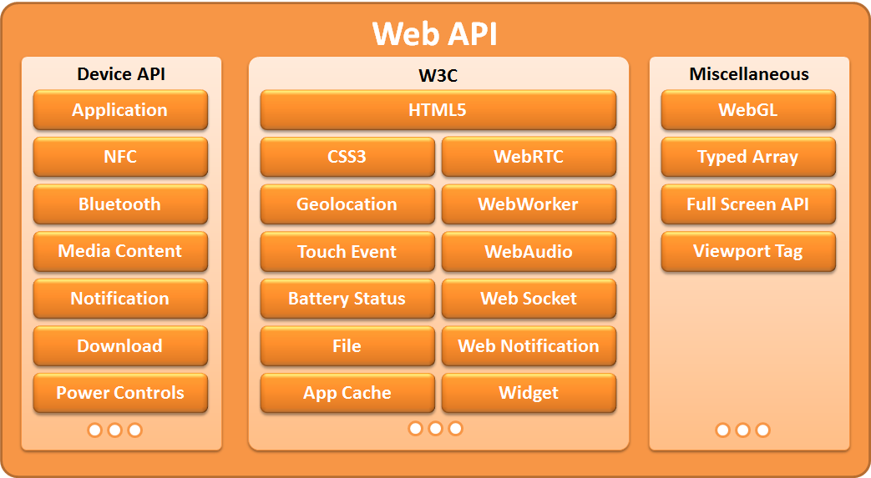

Tizen Web API is standard HTML5 and Tizen Device API. Using the Tizen Web APIs, programmers can develop rich Web applications and build great app experiences with well-known Web programming languages: HTML, CSS, and JavaScript. Just like every major browser in the market, the Tizen Web APIs support the latest HTML5 capabilities, such as animation, offline, audio, and video. By utilizing the standard HTML5 capabilities, your Web applications are ready to run across various devices and platforms with minimal customization. Additionally with JavaScript-based Tizen Device APIs, you can also enable advanced device access from your Web applications, such as Bluetooth, NFC, and geolocation.

Note Tizen Web API are not forking W3C APIs.

### Web Application

Web is the primary development environment for Tizen. SDK and many samples are available on Tizen site. All application developed with Titanium are Web Application. Titanium uses existing Mobile Web as UI framework for Tizen.

### Native Applications

Native application development is available for device implementers throw components in Core System. Native applications cannot be developed and deployed with Tizen SDK. Titanium does not supports native application development for Tizen